**Dept_nameSQL**

1. DISTINCT:

Unik degerleri cikarir.

SELECT DISTINCT sang FROM tracks;

SELECT DISTINCT AlbumId, MediaId FROM tracks;

1. WHERE:

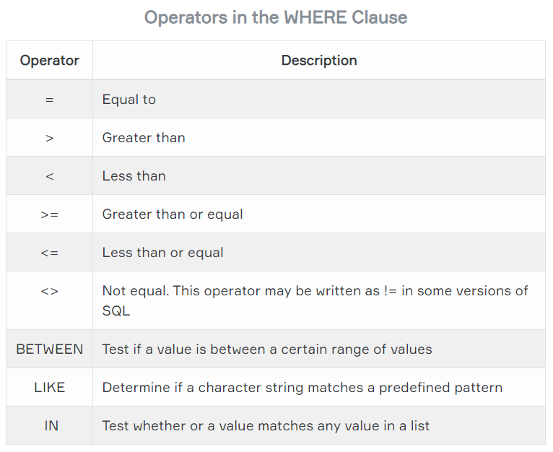

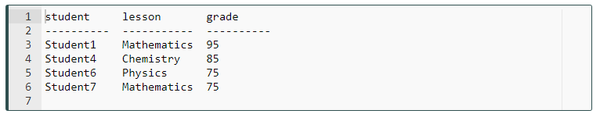

SELECT * FROM student_table where grade >= 80;

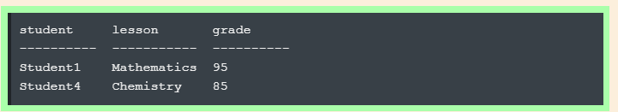

SELECT * FROM student_table WHERE lesson = "Mathematics";

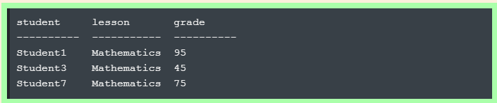

SELECT * FROM student_table WHERE grade < 60;

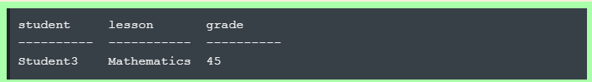

1. **LIMIT**:

SELECT * FROM student_table LIMIT 3;

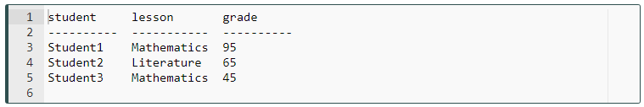

**SELECT * FROM student_table WHERE grade > 70 LIMIT 2;**

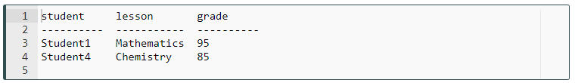

1. **ORDER BY:**

The ORDER BY keyword sorts the result-set in descending or ascending order.

SELECT column_name(s) FROM table_name ORDER BY column_name(s) ASC|DESC;

Herein **"|"** symbol means "use either ASC or DESC". If you don't use any of them, the default value is ASC (ascending order).

SELECT * FROM employees ORDER BY first_name ASC;

SELECT * FROM employees ORDER BY first_name;

SELECT DISTINCT first_name, salary FROM employees ORDER BY salary;

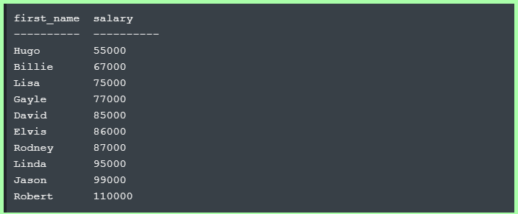

SELECT DISTINCT first_name, salary FROM employees ORDER BY salary DESC;

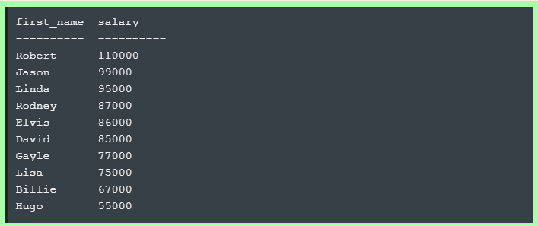

SELECT * FROM employees ORDER BY gender ASC, salary DESC;

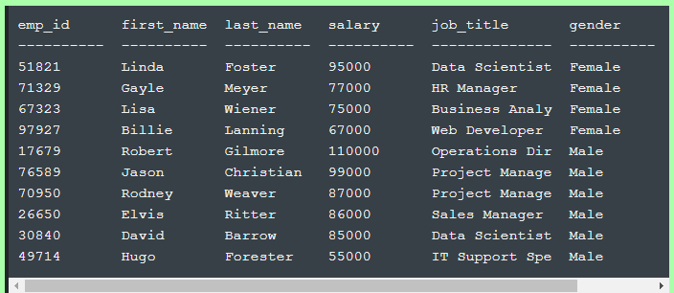

1. **ORDER BY clause with WHERE clause:**

SELECT column_name(s) FROM table_name WHERE condition ORDER BY column_name(s)s ASC|DESC;

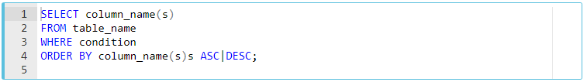

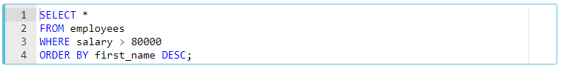

SELECT * FROM employees WHERE salary > 75000 ORDER BY gender, salary DESC;

SELECT * FROM employees WHERE salary > 75000 ORDER BY gender ASC, salary DESC;

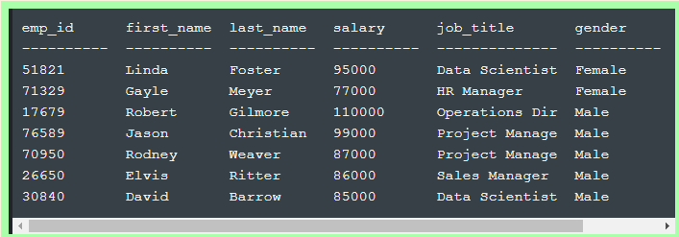

SELECT * FROM employees ORDER BY hire_date LIMIT 1;

En uzun sure calısan elemanı gosterir.

1. **OPERATORS:**
   1. **AND**; her iki kosulu saglayan sonuclari gosterir.

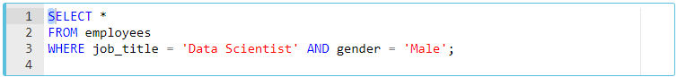

SELECT first_name, salary, job_title FROM employees WHERE gender = "Male" AND salary < 95000 AND salary > 56000 ORDER BY salary LIMIT 2;

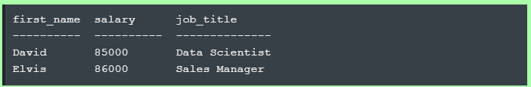

* 1. **OR**; iki kosuldan en az birinin TRUE olmasi durumundaki sonuclari gosterir.

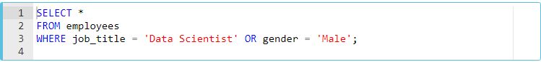

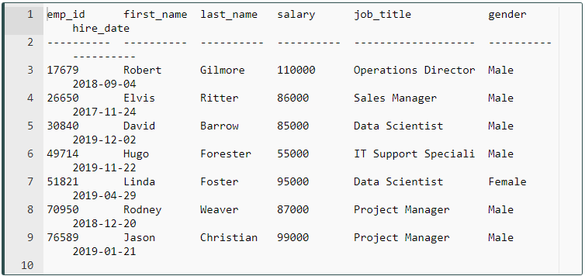

SELECT first_name, salary, job_title FROM employees WHERE gender = "Male" OR salary < 95000 AND salary > 56000 ORDER BY salary LIMIT 3;

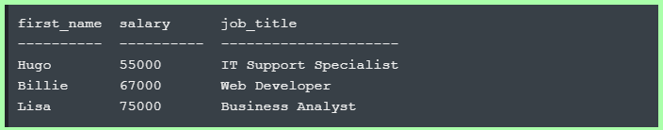

* 1. **NOT**: negatif anlaminda WHERE clause’un hemen arkasinda kullanilir.



SELECT first_name, salary, job_title FROM employees WHERE NOT gender = "Male" OR salary < 95000 AND salary > 56000 ORDER BY salary LIMIT 3;

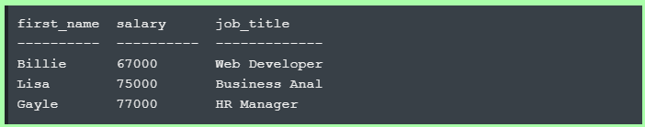

* 1. **BETWEEN … AND:**

SELECT * FROM employees WHERE salary BETWEEN 65000 AND 90000 ORDER BY salary LIMIT 3;

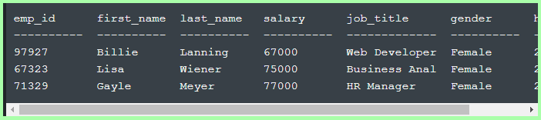

* 1. **NOT BETWEEN … AND:**



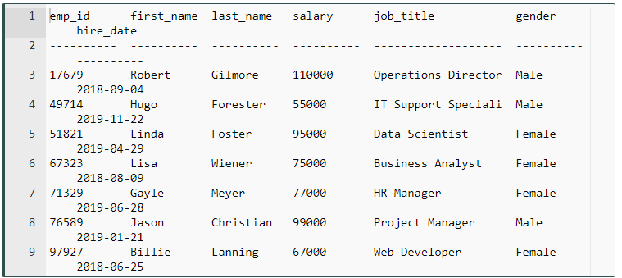

SELECT * FROM employees WHERE salary NOT BETWEEN 65000 AND 90000 ORDER BY salary LIMIT 3;

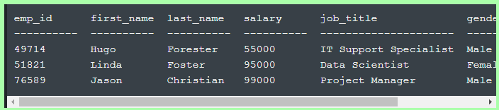

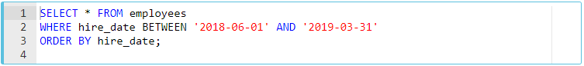

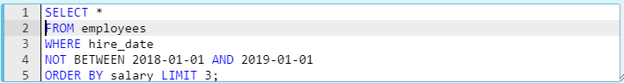

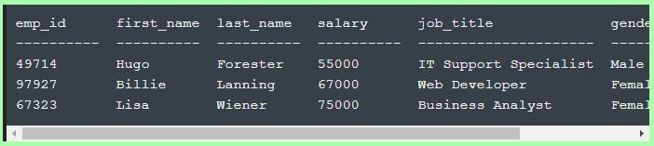

* 1. **IN:**

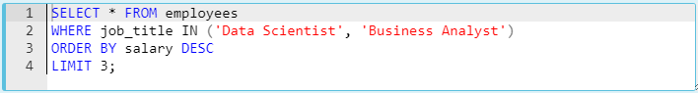

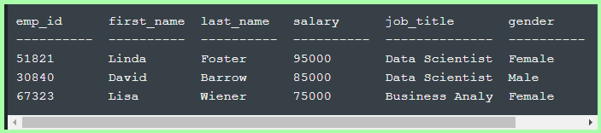

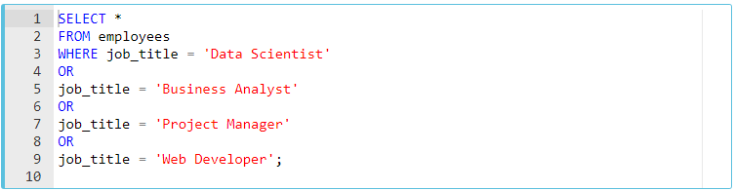

Yukardaki ile asagidaki

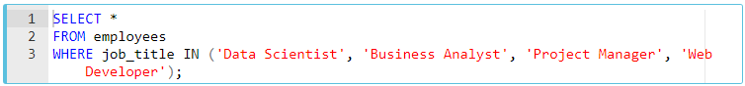

ayni sonucu verir.

SELECT * FROM student_info WHERE state = "Virginia" AND field IN ("Data Analysis", "Data Science", "DevOps");

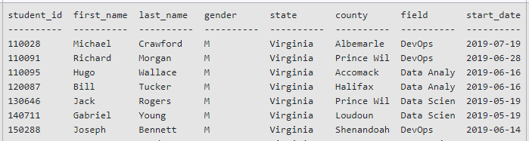

* 1. **NOT IN:**

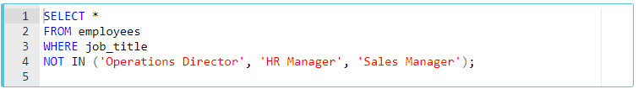

* 1. **LIKE**:

**Percent (%):**The % character matches any sequence of zero or more characters.

**Underscore (_ ):** The **_** character matches any single character. Tek karaktertir.

* 'Out%' pattern matches any string beginning with "Out" such as "Outro".
* 's%' pattern matches any string that starts with "s" such as "silk", "soup", etc.
* '%per%' pattern matches any string containing "per" such as "percentile" and "peeper".
* 's_n' pattern matches "son", "sun", etc.
* '__te' pattern matches "mate", "Kate", "kate", etc.

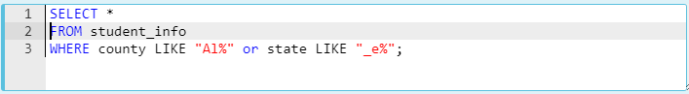

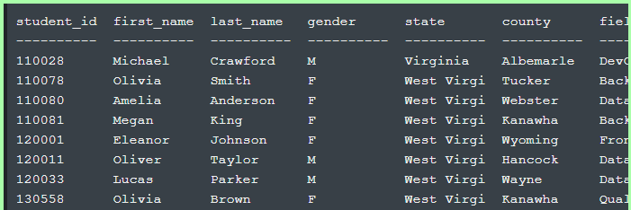

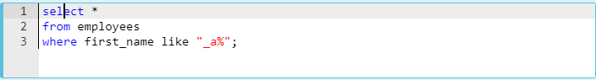

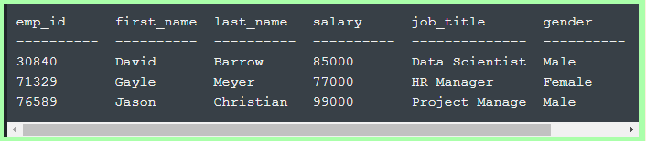

1. **AGGREGATE :**

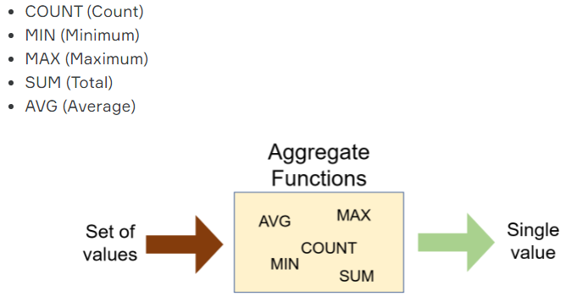

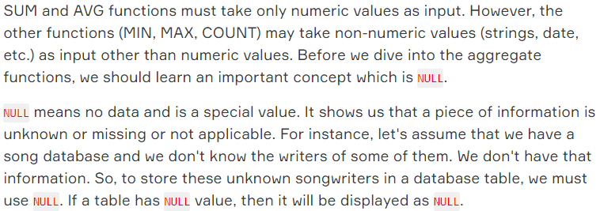

* 1. **COUNT:**

Ogrenci sayisi icin tum satir sayisini saydirabiliriz:

 = 32

AS: Isimleri kisaltmak icin veya tanimlanan yeni satiri isimlendirmek icin kullanilir.



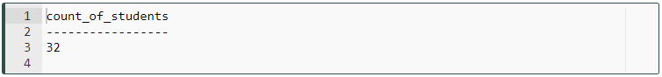

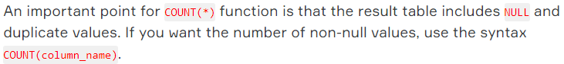

Unik degerler icin:



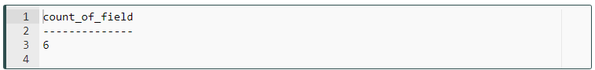

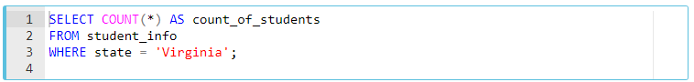

* 1. **MIN and MAX:**







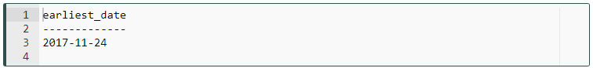

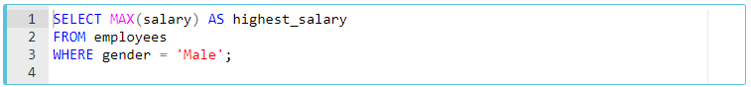

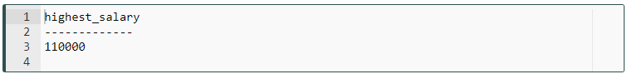

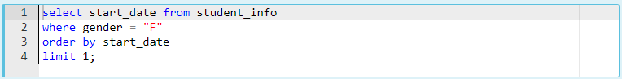

* 1. **SUM:**

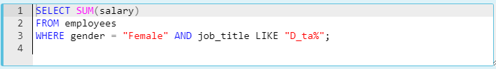

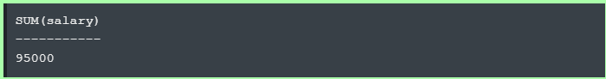

* 1. **AVG:**

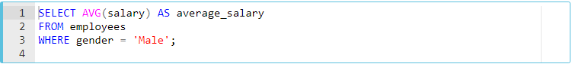

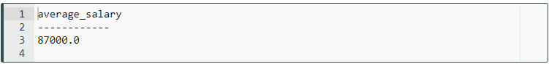

NULL degerleri gormezden gelir.

1. **GROUP BY:** 
   1. **GROUP BY with COUNT:**

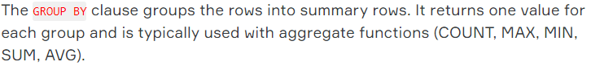

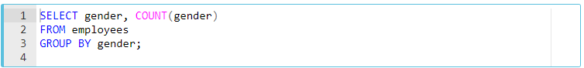

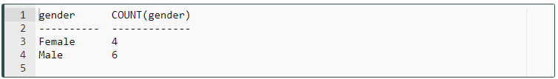

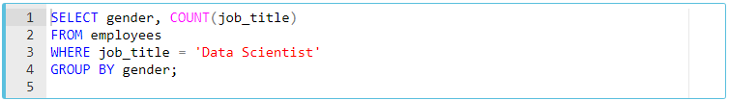

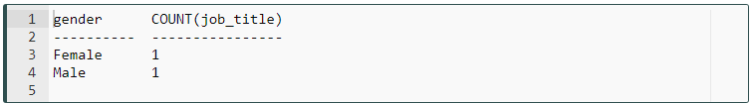

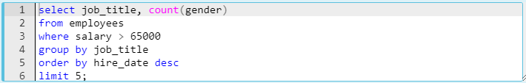



* 1. **GROUP BY with MIN & MAX:**

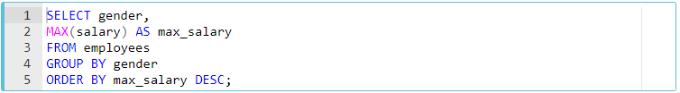

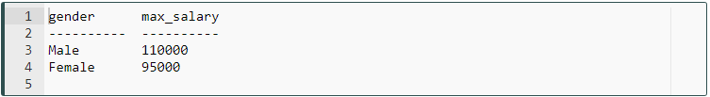

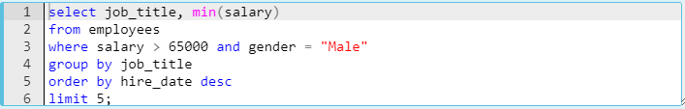



* 1. **GROUP BY with SUM & AVG:**

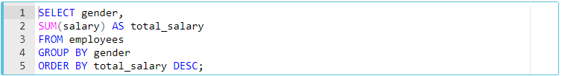

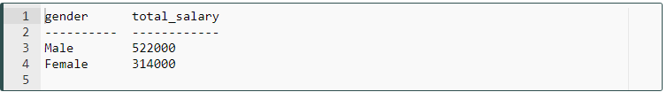

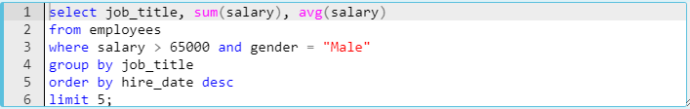



1. **JOIN:**

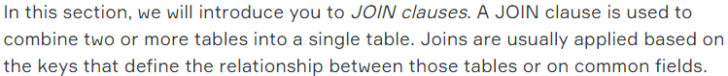

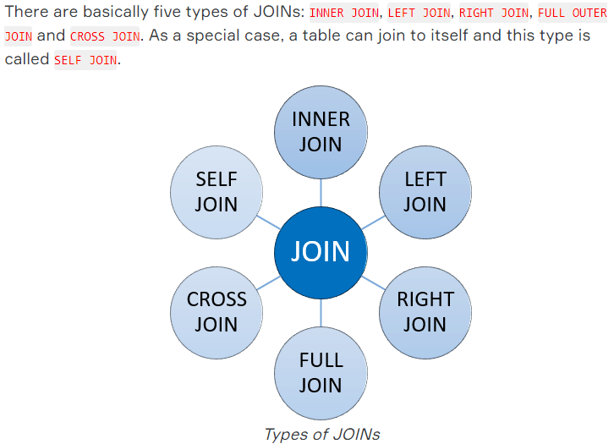

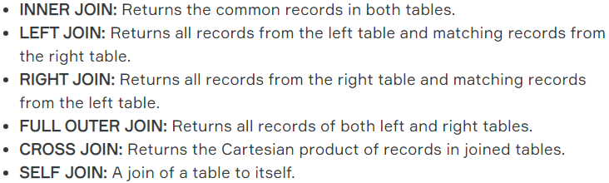

* 1. **INNER JOIN … ON … :**

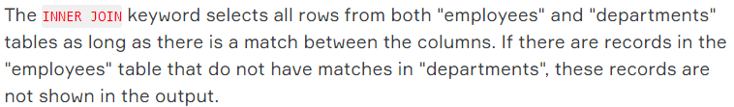

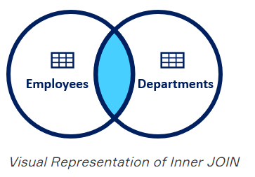

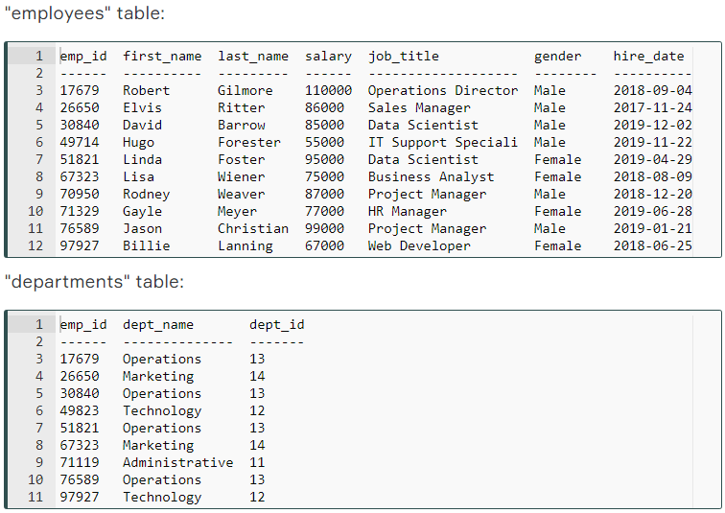

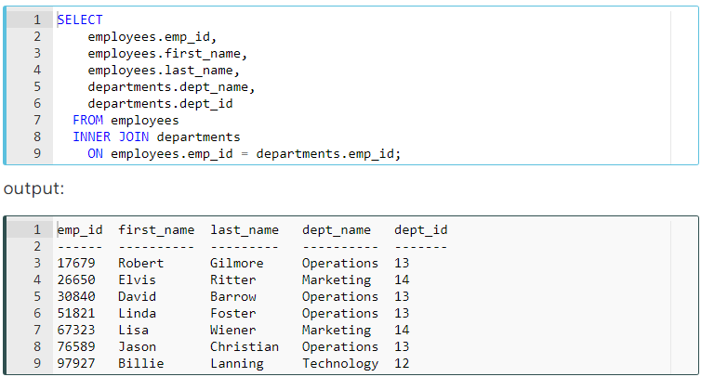

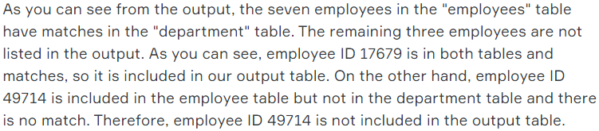

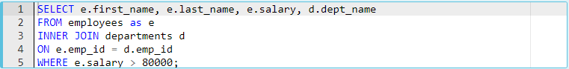

* 1. **LEFT JOIN … ON … :**

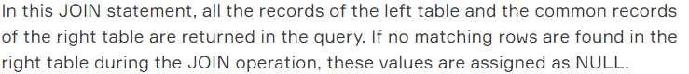

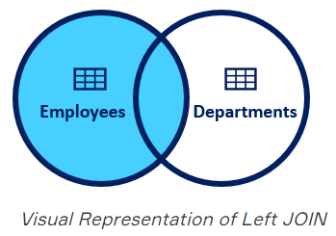



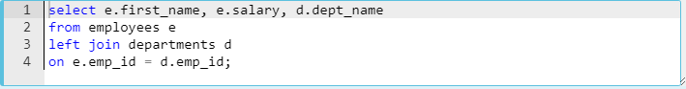

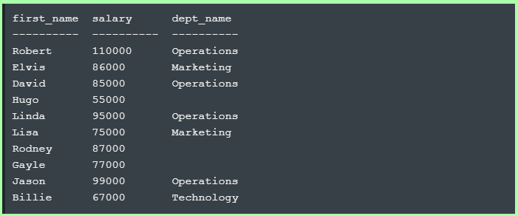

1. **SUBQUERY**:

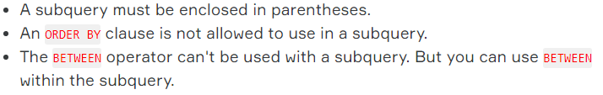

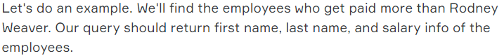

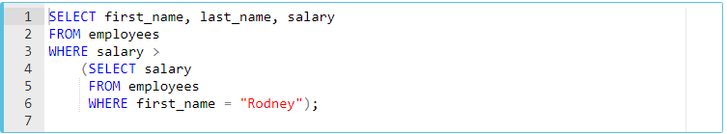

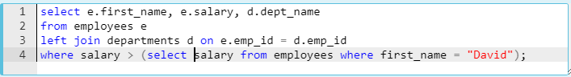

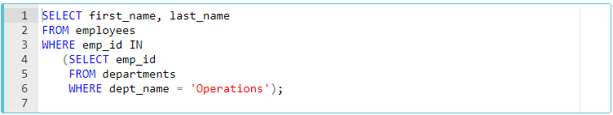



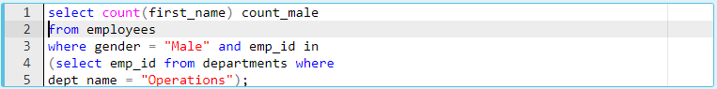

1. **DDL COMMANDS:**

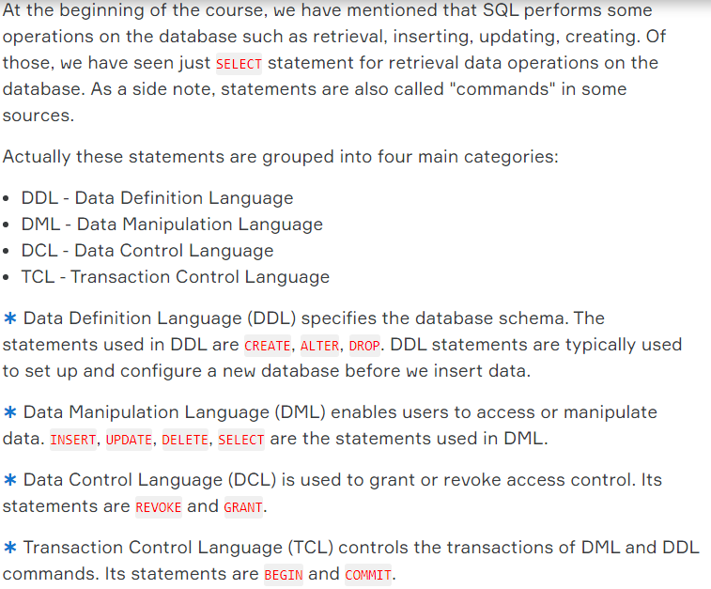

* 1. **typeof**:

Datanin tipini gosterir.

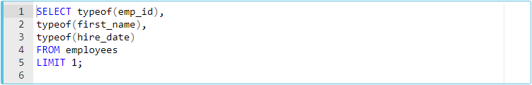

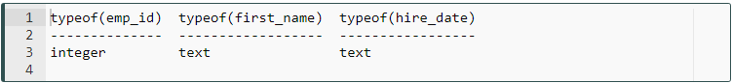

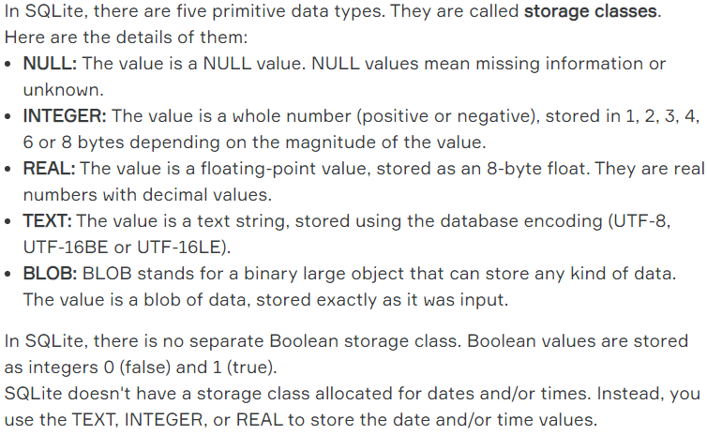

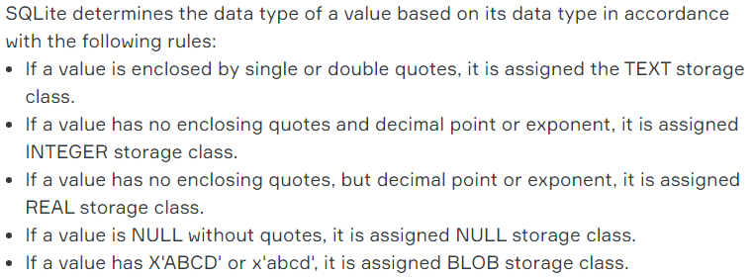

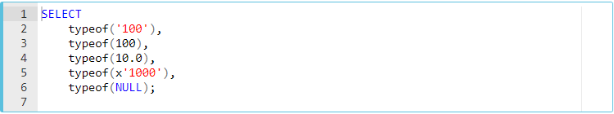

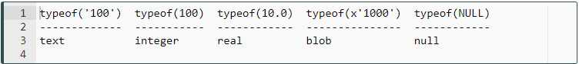

1. **CREATE TABLE:**

Oncesinde database olabilir veya olmayabilir.

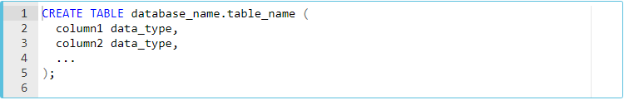

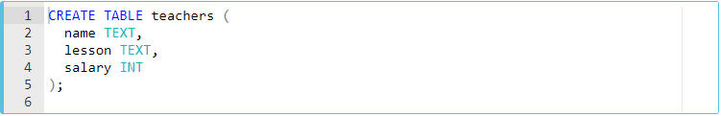

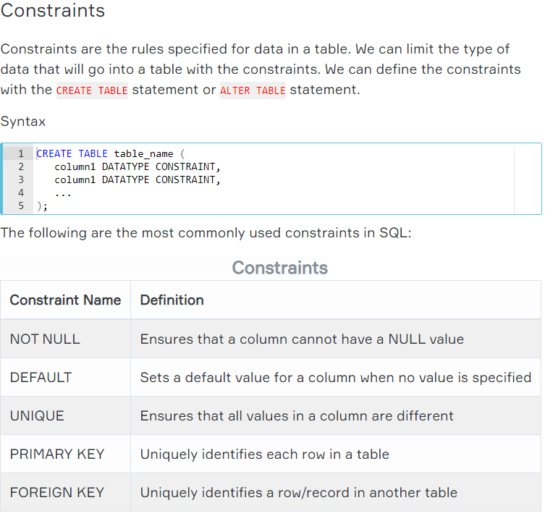

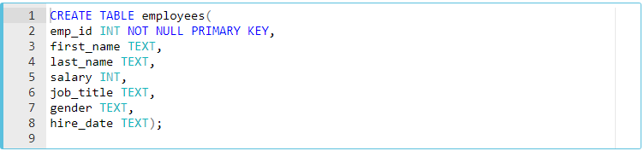

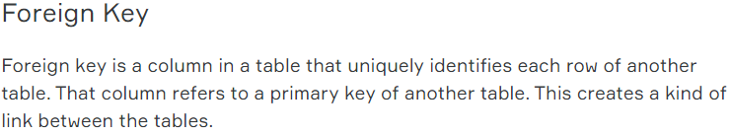

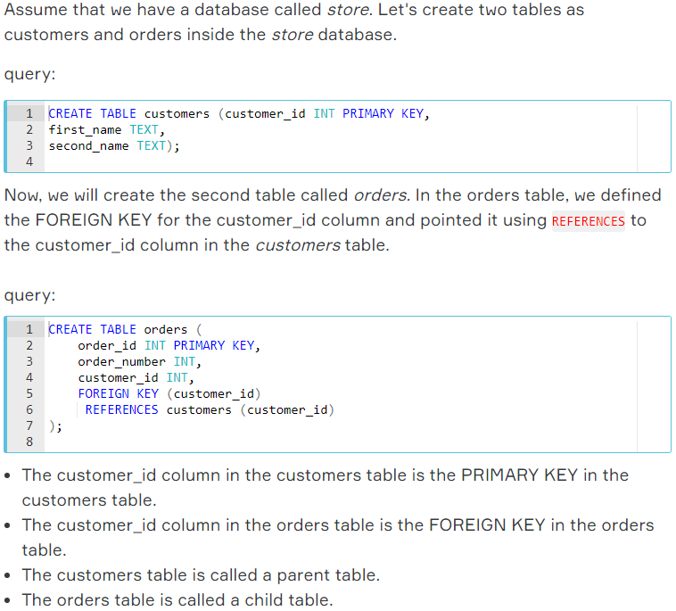

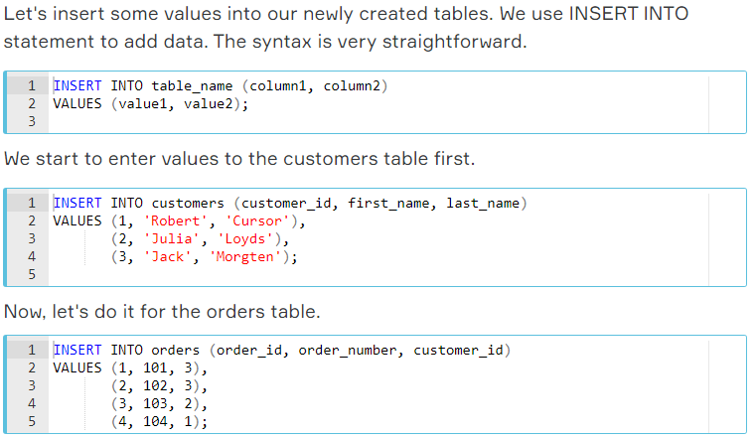

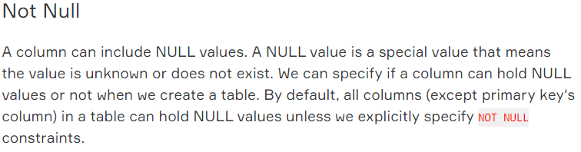

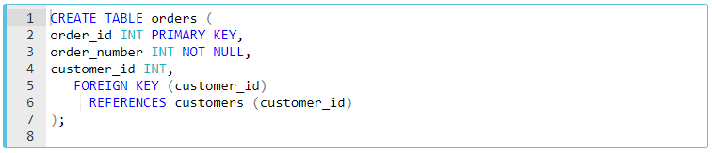

1. **ALTER TABLE & DROP TABLE:**

